Precision Rectifier
A precision rectifier is a special type of rectifier circuit that uses an operational amplifier (op-amp) along with diodes to convert AC signals into DC accurately, even for very small input voltages . In normal rectifiers, silicon diodes need about 0.7 V to start conducting, which means weak signals get lost or distorted. Precision rectifiers solve this problem effectively.
The op-amp boosts the input signal and compensates for the diode’s voltage drop, allowing the diode to conduct even when the input is very small. This makes it possible to rectify low-level signals without any noticeable distortion .
Precision rectifiers are mainly of two types:
Half-wave Rectifiers:
A half-wave rectifier allows only one half of the signal to pass
Full-wave rectifiers:
Converts both positive and negative halves into a single direction output.

Applications:
These circuits are commonly used in instrumentation, signal processing, audio systems, and measurement devices, where accuracy is very important.
Conclusion:
In short, precision rectifiers are very useful circuits that help in accurately processing low-voltage signals by overcoming the limitations of ordinary diode rectifiers.

Half Wave Rectifier:
The circuit was designed using LTSpice to demonstrate a half-wave precision rectifier, which is used to rectify small input signals (less than 0.7 V). Unlike conventional rectifiers, this circuit uses an operational amplifier to eliminate the diode threshold limitation. However, a drawback of this circuit is that it rectifies only one half-cycle of the input signal, while the other half is clipped.
Setup:
INPUT: Sine wave(0.5 V, 10 Hz)
OUTPUT: The negative wave is inverted and positive is blocked, the output is obtained.
1.Circuit Diagram.
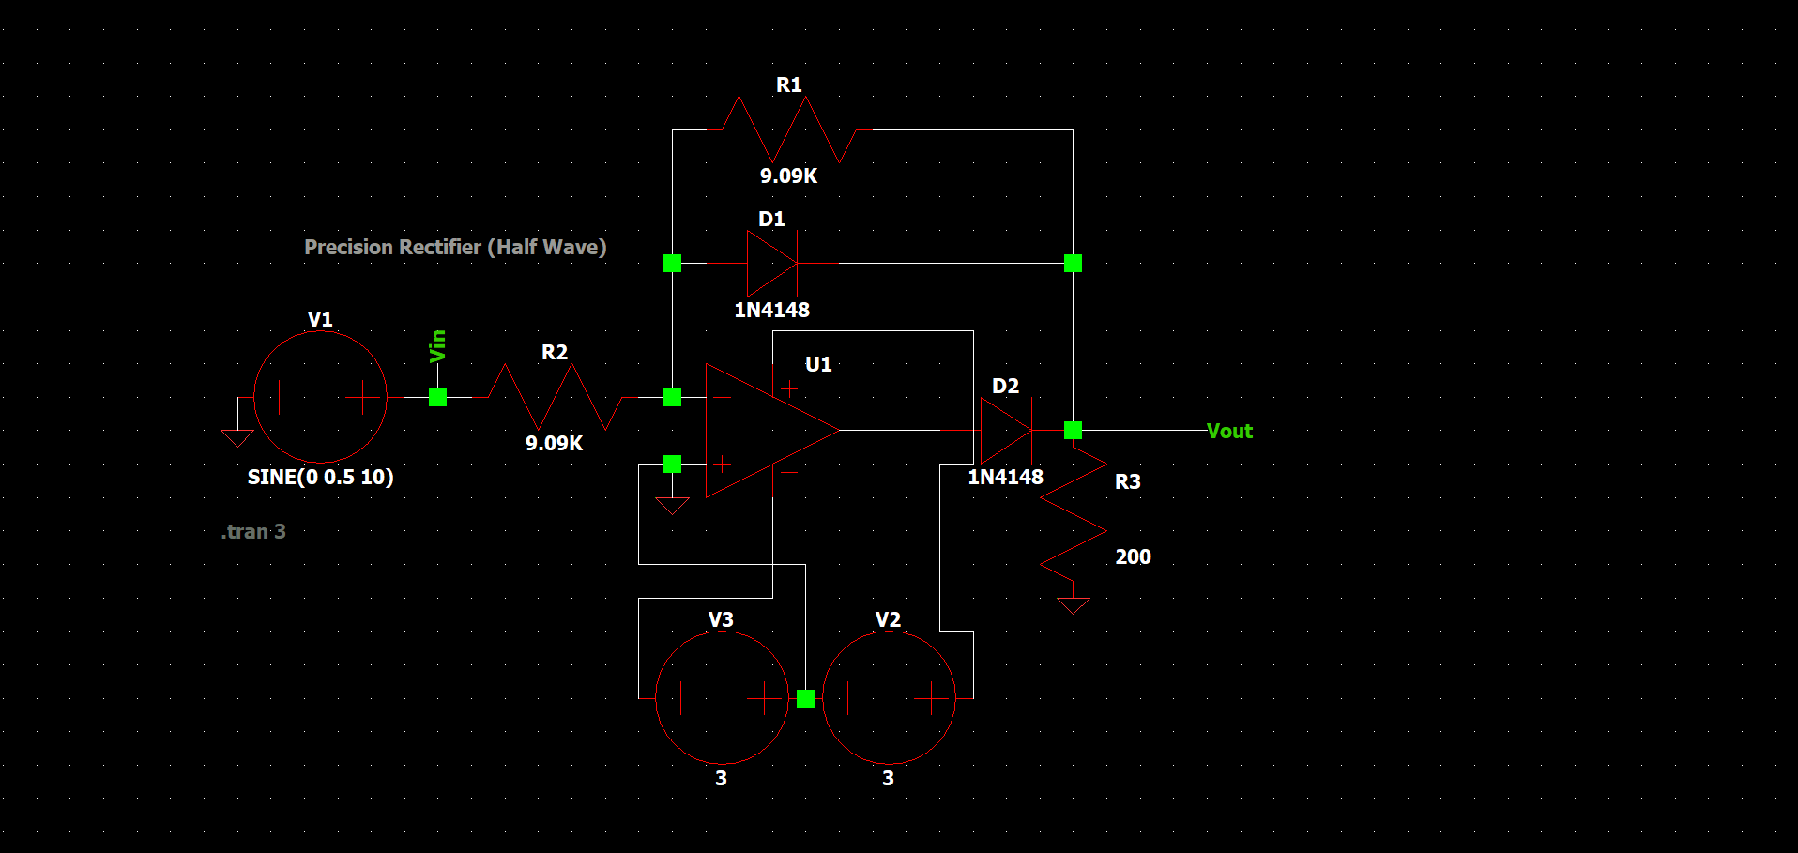
2.Waveform.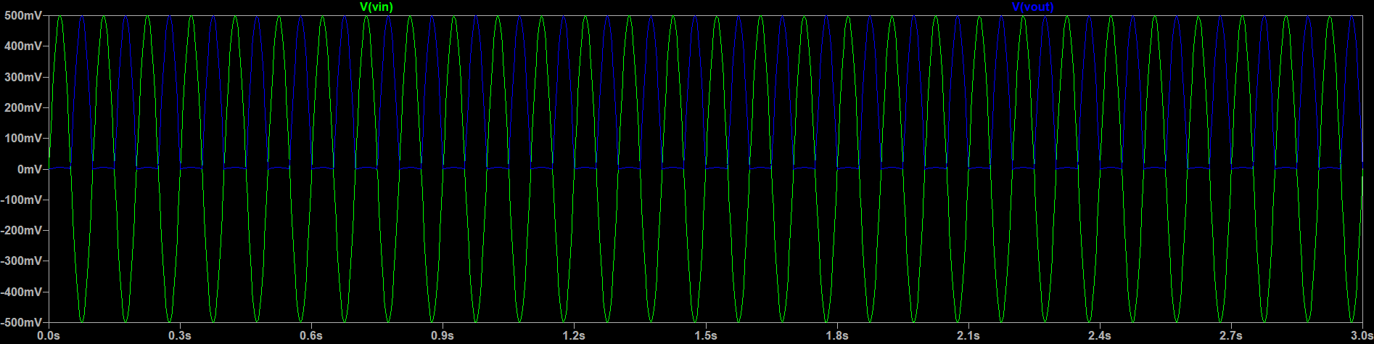3.Components Used:
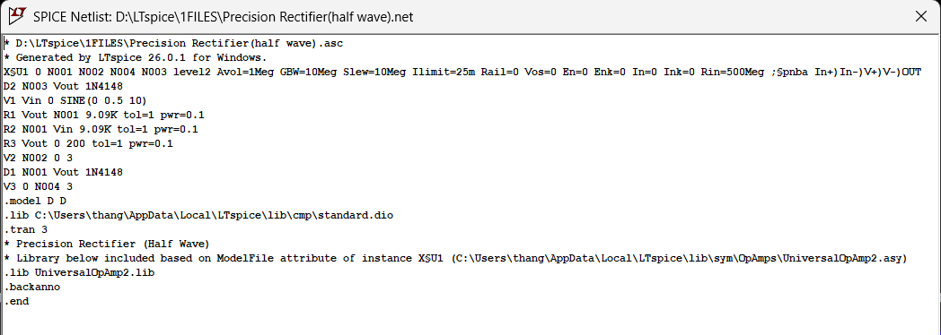
Full Wave Rectifier:
The circuit was designed in LTSpice to demonstrate the full wave rectifier, this used to rectify small input(<0.7 V). The major difference here is there is no clipping in the output wave, Full wave is rectified.
Setup:
INPUT: Sine wave(0.5 V, 10 Hz)
OUTPUT: The output is pulsating DC wave, Both half are rectified, so no signal portion is loss.
1.Circuit Diagram.
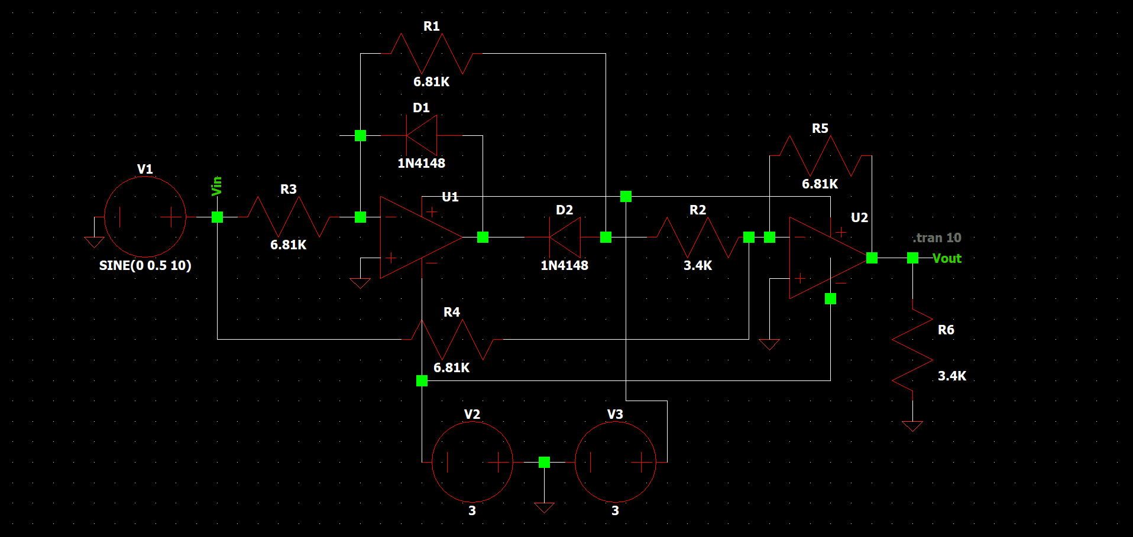2.Waveform. 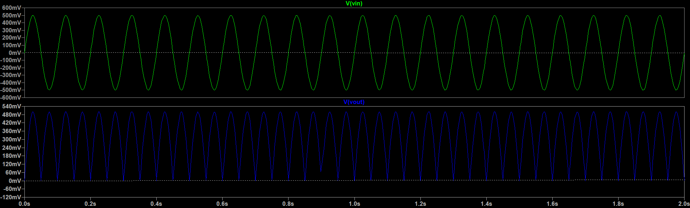3.Components Used.